**1.** **Introduction**

The goal of the project is to create a web application where the pizzeria owner gets an overview of what's going on in the business, such as current orders, current employees. Furthermore, to keep various statistics, to keep track of the quantity of ingredients. With this application, pizzeria's everyday life will be greatly simplified, current affairs will be clearer, and all users of the application will benefit from a reliable system based on modern technologies.

**2.Project plan**

The shop manager will have the greatest "power" in the program, he is, the person to whom all data is viewable, can change the role of other users. The admin, just like a shop manager, will have the authority to change the role of the users to make the shop manager's job easier, but the admin will not have the right to query all other data, only the business manager can. Other users have minimal privileges (placing orders).

People working on the app:

|  |  |
| --- | --- |
| Dávid Lázár | third year university student (computer science, Eszterházy Károly University - TTK) |
| Norbert Nagy | second year university student (computer science, Eszterházy Károly University - TTK) |
| Gergő Soós | second year university student (computer science, Eszterházy Károly University - TTK) |
| Máté Szondi | second year university student  (computer science, Eszterházy Károly University - TTK) |
| Ádám Agócs | second year university student  (computer science, Eszterházy Károly University - TTK) |

**3.** **Business Process Model**

Current business process model:

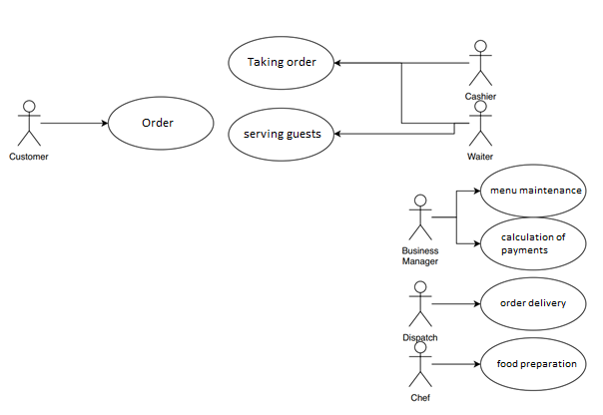

The whole system is currently paper based. If someone would like to order from the pizzeria, you can do so only by phone and you can get information from the assortment there, or if you have a flyer at home. As a result, the customer does not even know if the company has the food in question, only by calling the restaurant and asking. The chefs have no systematic work, they cannot keep track of what they are running out of. It is not possible at this time to keep statistics on their best or least consumed foods.

They cannot keep track of their customers, so they can't give them loyalty discounts. The waiter in the restaurant picks up the order, writes it down on a piece of paper and delivers it to the kitchen. Payments are also determined on paper. Couriers are given paper addresses on where to go and what to deliver, which has been a mess before.

Model of required business processes:

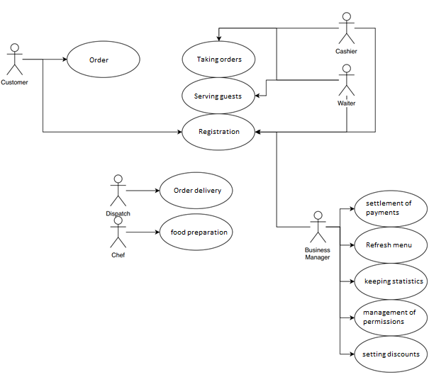

On the homepage of the site, it can be chosen if a user

or an employee would like to enter the system. (This is always the subject of the registration.)

User must provide:

* Name
* Address
* Phone number

Guests can order home via the website. They choose from the food available, what they want to order, to what address, when and how to pay (by credit card or cash - in forints).

So that guests have their own account, you can keep track of them

(Those who order at least 10000HUF will receive a 10% discount on the following month.) The restaurant could place orders online, which would improve wait times. Choose from the available meals what you would like to order and how you want to pay (euro-forint-credit card).

You can keep track of the food and its ingredients on the employee interface.

Statistics can be kept on what foods consumers consume; how much they spend at the pizzeria.

You can keep track of which employee worked for a given month,

then calculate your salary based on that.

Daily / yearly statistics, reports in the Admin interface.

**4.** **Functional Description**

The menus will be visible to all roles, but clicking on them will cause different roles to may receive different error messages, obviously who not be allowed to access the information they can't step the next page.

The most common use cases for the app are take orders, and queries and tracking of various information with "managerial" permission.

**5**. **Physical environment**

The application will be able to run on any operating system, since it is a web application, the code we make can be interpreted by different browsers. As a result, it does not require huge resources, a dual-core processor, and a PC / laptop with 2-4GB of RAM (RAM) can run the application without fail.